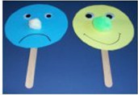
- You can take 2 circles draw eyes, nose and a happy smile to make a Happy Face :)
- Draw eyes, nose and a sad emotion to make sad face :(
Dear Children
Ready for today’s task: )

