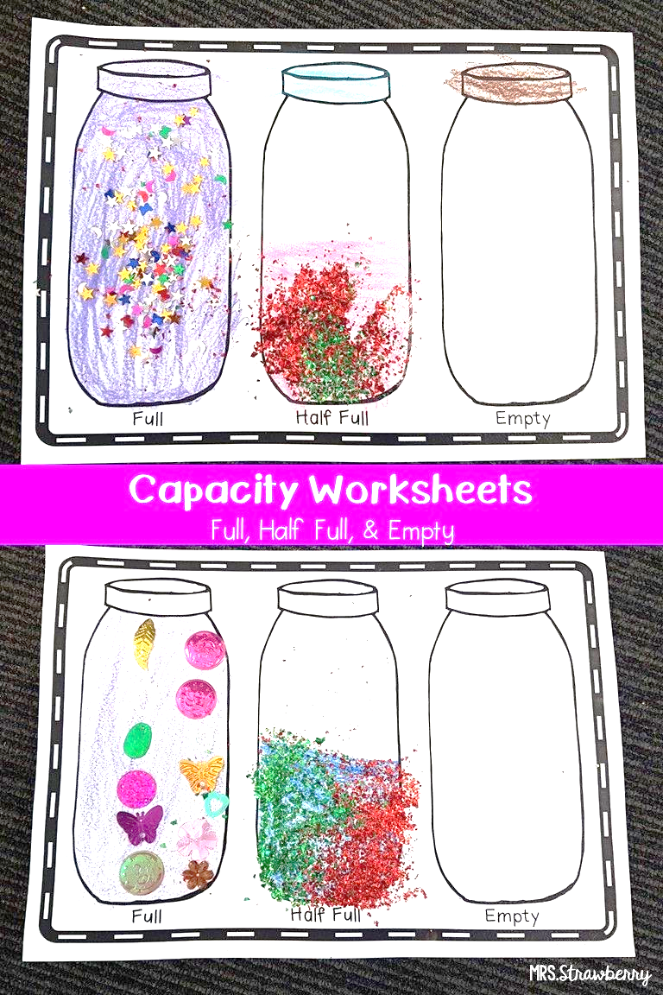
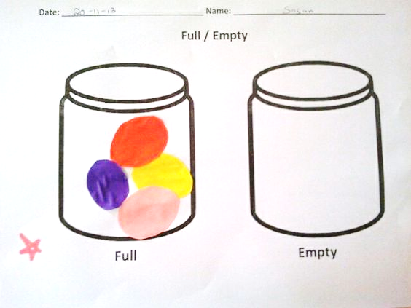
Hello Dear Children
Are you ready for today’s task?
Draw two glasses /boxes/baskets /plate etc whatever you want .Colour one object or you can paste circles etc. on any A4 size paper or in your H.W copy , and make it full .Keep the other one empty as given in the sample picture .So this way one will be full and other will be empty

